NMF, IV-2005

How to Establish and Visualize Relationship Assertions
for Taxonomic Concepts – A Primer

Purpose: To familiarize our users (presently: Jones & Riddle) with SEEK's approach to modeling and resolving taxonomic data in preparation for the tool design session in Albuquerque, April 25-26, 2005.

Contents:

I. Taxonomic Names and the Mammal Use Case 2
II. How Are the Synonymy Relationships Established? 2
III. To What Degree Do Names and Their Relationships Trace Taxonomic Opinion? 2
IV. The Taxonomic Concept Approach 3
V. Some Ways to Represent Real-Life Concepts and Their Relationships 4
A. Koperski et al. (2000) – Checklist of German Mosses 4
B. Weakley (2005) – Andropogon Grasses in the Carolinas 5
C. Franz (2005) – Two Higher-Level Classifications of Weevils 7
VI. Visualization Tools for Concepts and Their Relationships 13
A. Martin Graham's Tool – Multiple Hierarchy Version 13
B. Martin Graham's Tool – Graph Version 15
C. Schema Matching Tool SCIA 16
D. DoubleTree 17
E. Other Tools 19
VII. In Preparation for the Albuquerque Design Sessions 22
VIII. References 23
IX. Appendix 1: Mini-Introduction to the SEEK Taxonomic Object Service 24

I. Taxonomic Names and the Mammal Use Case

We want to achieve a new kind and quality of taxonomic resolution, to be implemented in the mammal use case. Taxonomic names will be a common entry point into the niche modeling workflow. For example, an ecologist might want to analyze the distributional data for a particular mammal species, genus, or family. Given the data networked through MaNIS, the most precise identification of a data record would be to the level of subspecies, possibly with author name. A typical MaNIS record might read "Felis silvestris" (wild cat).
We know that over time the nomenclatural or taxonomic status of names can change from valid to invalid. Names may be spelled incorrectly and must be amended. They may be synonymized. The on-line Mammal Species of the World lists 5 such synonyms for "Felis" and 88 for "Felis silvestris."
If an ecologist wishes to analyze the distribution of Felis silvestris (sensu MSW) then our resolution service should also look in MaNIS for records filed under any of the now invalid names for this species. This will be possible once the Taxonomic Object Service (TOS, see Appendix 1) stores both the valid name and all known synonyms. We may then expand the ecologist's search command accordingly and extract a more complete dataset from MaNIS to perform the niche modeling.

II. How Are the Synonymy Relationships Established?

A wide range of judgments about the validity of taxonomic names can be made through "pure literature study." For example, by hitting the books one can detect that the gender (declination) of the genus name and the species epithet do not match up in Latin, or that homonymy (same name, different taxon) requires the younger name to be replaced. The Code of nomenclature calls these relationships between an invalid original name and a valid replacement name "objective."
Subjective relationhips, on the other hand, are ultimately based on judgments about the identity of type specimens. The genus Microfelis Roberts (1926) is a junior synonym of Felis L. (1758), which means that someone (possibly Pocock, 1951) examined the type specimen for each name and considered them taxonomically equivalent. There was nothing wrong with the name "Microfelis" until that assessment was made. Today another taxonomist could in principle judge the type specimen for Microfelis to be sufficiently distinct from Felis to warrant a status resurrection (valid in 1926 => synonymized in 1951 => resurrected in 2005).

III. To What Degree Do Names and Their Relationships Trace Taxonomic Opinion?

In the course of time the taxonomic process can lead to many-to-many matches between names and the underlying taxonomic perspectives. The 88 synonyms of F. silvestris Schreber (1775) are supposedly all referring to the same species. On the other hand, and especially at higher ranks (genus, family), the information content of the same name can change dramatically over the years through addition and subtraction of subordinate taxa. So long as the original name-bearing type remains connected to the valid higher-level name, these lower-level rearrangements will have no nomenclatural effect.
Taxonomic definitions of names are pretty complicated objects. Often when a new name is coined ("Felis silvestris"), it is meant to refer not only to the holotype specimen but perhaps to a whole series of specimens deposited in a museum at the time. Then there is a textual diagnosis – skull morphology, tooth formula, size, etc. – which (arguably) is meant to refer to specimens not even examined in that instance. These "non-holotype" parts of a name definition are taxonomically significant, but different opinions as to their validity or accuracy will not affect the validity of the name itself – unless the holotype is involved.
Although Linnaean names are commonly thought to adjust to taxonomic information content, they do so only to the extent that there are new judgments about the similarity of holotypes and the relative hierarchical position of names, especially at the genus-species intersection. In that sense, names track taxonomic perspectives only to a degree of approximation. A more precise approach would take all aspects of a taxonomic definition into consideration.

IV. The Taxonomic Concept Approach

SEEK is adopting the "concept approach" (Berendsohn, 1995) to model the taxonomic process to a finer degree of precision and thereby overcome the problem of many-to-many matches of names and taxonomic perspectives. The core principle of the concept approach is to track the history of different name uses by linking them to the respective authors via a "sec." (abbreviation for the Latin secundum, according to). Instead of managing just names, we handle names as defined in a particular treatment by a particular expert. For example, the name "Felis L." can be represented as part of one concept "Felis L. sec. Linnaeus (1758)," and also in another concept "Felis L. sec. Wilson & Reeder (1993)."
This convention of separating out the use of the name according to different authors who first defined it or later revised it opens up new possibilities. We can now compare the definitions of names while taking into account all their taxonomically relevant elements, not just the types. We can create a concept lineage for "Felis L." and trace all taxonomic changes from 1758 to 2005.
The comparisons themselves can be conceived and visualized in numerous ways. The goal for the Albuquerque tool design session is to determine how this process of comparing concepts would "feel best" to our users. Meaning, we want to find out how they typically like to look at individual and then multiple classification schemes (at least two), and what details they would want to see and enter in the process of relating the represented concepts (sec. A vs. sec. B) to each other.
The next section will show some practical examples of how other experts have approached this task.

V. Some Ways to Represent Real-Life Concepts and Their Relationships

A. Koperski et al. (2000) – Checklist of German Mosses

These authors used the concept approach to record changes in German moss taxonomy from 1927 to 2000. They adopted six new symbols to express these relationships (Fig. 1):

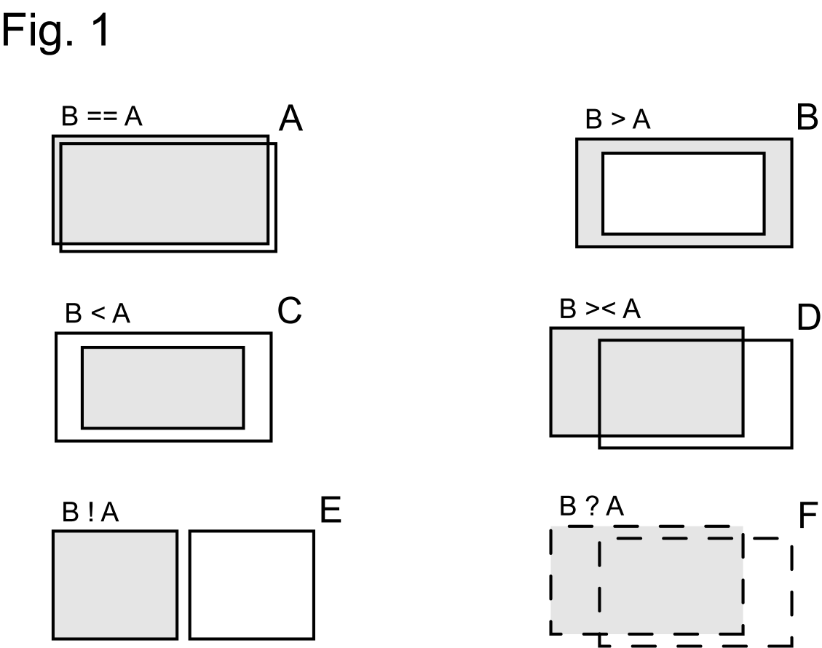

A: == congruent – concepts A & B have the same circumscription
B: > includes – concept B has a wider circumscription than concept A
C: < is included in – concept B has a narrower circumscription than concept A
D: >< overlap – concepts A & B have some constituents in common, in addition each concept
has other constituents not shared with is counterpart
E: ! excludes – concepts A & B have no overlap at all
F: ? ambiguous – not clear what the relationship is, perhaps because either A or B are
not well defined

The authors derived these symbols and meanings from set theory. Symbols A to E are meant to be entirely exclusive of each other in their meanings. That is, "overlap" (D) is defined narrowly as being different from "congruent" (A), or partial inclusion (B and C).

- (1) The TOS supports these kinds of relationship symbols, although currently we prefer using
the symbol "|" for exclusion (A | B) rather than the exclamation point which sometimes
intuitively means "I agree."
- (2) We also recommend not using the "?" to express ambiguity or uncertainty in a judgment,
but instead to use "AND" and "OR," e.g. "A = = B OR A > B."
- (3) Finally, we allow use of the symbols "+" (plus) and "–" (minus), on each side of the
equation, if and when they offer additional ways to express congruence in two classification
schemes, e.g. "A + B = = C."
Here is a real-life example from the moss dataset (Fig. 2):

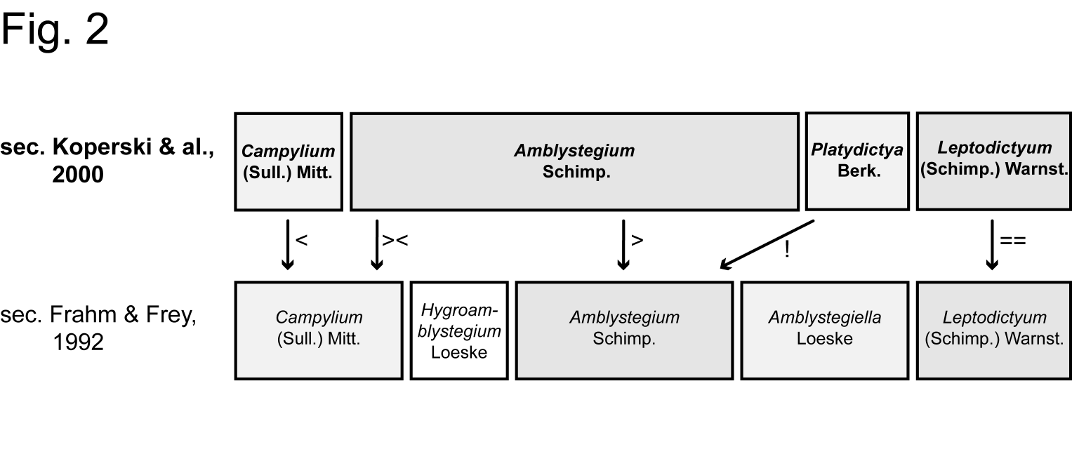
Shown are parts of two classifications of 4 and 5 genera, respectively, which in their entirety make up a congruent set. The breadth and position of each bar representing a particular genus concept is obtained by examining its constituent species (restricted to Germany in this case). For example, the concept Amblystegium Schimp. sec. Koperski et al. (2000) contains 8 species concepts, whereas Amblystegium Schimp. sec. Frahm & Frey (1992) contains only 3 species concepts. The latter authors were certainly aware of the other 5 species concepts but placed them in 3 other generic concepts (Fig. 2). Therefore:

- Amblystegium Schimp. sec. Koperski et al. (2000) > Amblystegium Schimp. sec. Frahm & Frey (1992)
- Amblystegium Schimp. sec. Koperski et al. (2000) >< Amblystegiella Loeske sec. Frahm & Frey (1992)
- Campylium (S.) Mitt. sec. Koperski et al. (2000) < Campylium (S.) Mitt. sec. Frah & Frey (1992)
- etc.

This example illustrates clearly how alternative taxonomic perspectives are only partly encoded in the names used, and how the concept approach permits a more precise documentation of the similarities and differences.

B. Weakley (2005) – Andropogon Grasses in the Carolinas

Alan Weakly recently put together a comprehensive concept linage (1889 to 2005) for the grass genus Andropogon L. (bluestem). His representation deviates somewhat from the moss data. In all he identified 24 lowest-level concepts that were recognized at one point or another. Several of these are subspecies or varieties. Table 1 shows where each of the authors have stood in terms of acknowledging and grouping these elementary concepts, and under what names they have treated them.
"X" means that an author did not mention a concept, "?" means ambiguity. The red color indicates stability both in name and circumscription, whereas the blue color indicates instable nomenclature (spelling, rank) but stable taxonomy.

Three species-level concepts (sec. Weakley, 1995!) are explicitly traced throughout. They are: (1) Andropogon virginicus (yellow), (2) Andropogon glomeratus (orange), and (3) Andropogon scoparium (green).
The coloration shows how each of Weakley's current (2005) concepts acquired and lost sub-elements since 1889. Relationship symbols (see above) could easily be derived from this analysis. No two authors agree on the nomenclature and taxonomy of the group as a whole.

Table 1. Concept lineage for Andropogon sec. Weakley (2005).

Concept | Weakley 2005 | C. Campbell (1983, FNA 2003) | Godfrey & Wooten 1979 | RAB 1968
1 | Andropogon gerardii | A. gerardii | A. gerardii | A. gerardii
2 | Andropogon capillipes var. capillipes | A. virginicus var. glaucus "drylands" | A. capillipes | A. virginicus
3 | Andropogon capillipes var. dealbatus | A. virginicus var. glaucus "wetlands" | A. capillipes | A. virginicus
4 | Andropogon virginicus var. virginicus | A. virginicus var. virginicus "old-field" | A. virginicus var. virginicus | A. virginicus
5 | Andropogon virginicus var. virginicus | A. virginicus var. virginicus "smooth" | A. virginicus var. virginicus | A. virginicus
6 | Andropogon virginicus var. decipiens | A. virginicus var. decipiens | A. virginicus var. virginicus | A. virginicus
7 | Andropogon glaucopsis | A. glomeratus var. glaucopsis | A. glaucopsis | A. virginicus
8 | Andropogon glomeratus var. hirsutior | A. glomeratus var. hirsutior | A. virginicus var. abbreviatus | A. virginicus
9 | Andropogon glomeratus var. glomeratus | A. glomeratus var. glomeratus | A. virginicus var. abbreviatus | A. virginicus
10 | Andropogon tenuispatheus | A. glomeratus var. pumilus | A. virginicus var. abbreviatus | A. virginicus
11 | Andropogon perangustatus | A. gyrans var. stenophyllus | X | ?
12 | Andropogon elliottii | A. gyrans var. gyrans | X | A. elliottii
13 | Andropogon longiberbis | A. longiberbis | X | X
14 | Andropogon tracyi | A. tracyi | X | X
15 | Andropogon ternarius var. ternarius | A. ternarius var. ternarius | X | A. ternarius
16 | Andropogon brachystachyus | A. brachystachyus | A. brachystachys | X
17 | Andropogon arctatus | A. arctatus | X | X
18 | Andropogon mohrii | A. liebmannii var. pungensis | A. mohrii | A. mohrii
19 | Schizachyrium scoparium var. scoparium | S. scoparium var. scoparium | S. scoparium | A. scoparium
20 | Schizachyrium scoparium var. stoloniferum | S. scoparium var. stoloniferum | S. stoloniferum | A. scoparium
21 | Schizachyrium littorale | S. littorale | S. littorale | A. scoparium
22 | Bothriochloa barbinodis | B. barbinodis | X | X
23 | Bothriochloa ischaemum var. songarica | B. ischaemum | X | X
24 | Bothriochloa laguroides ssp. torreyana | B. laguroides ssp. torreyana | X | X

Table 1. Concept lineage for Andropogon sec. Weakley (2005), continued.

Concept | Hitchcock & Chase 1950 | Blomquist 1948 | Small 1933 | Hackel 1889
1 | A. gerardii | A. furcatus | A. provincialis | A. provincialis
2 | A. capillipes | A. capillipes | A. capillipes | A. virginicus var. glaucus subvar. glaucus
3 | A. capillipes | A. capillipes | A. capillipes | A. virginicus var. glaucus subvar. dealbatus
4 | A. virginicus var. virginicus | A. virginicus var. virginicus | A. virginicus | A. virginicus var. viridis subvar. genuinus
5 | A. virginicus var. virginicus | A. virginicus var. virginicus | A. virginicus | A. virginicus var. viridis subvar. genuinus
6 | A. virginicus var. virginicus | A. virginicus var. virginicus | A. virginicus | A. virginicus var. viridis subvar. genuinus
7 | A. virginicus var. glaucopsis | A. virginicus var. glaucopsis | A. glomeratus | A. macrourus var. glaucopsis
8 | A. virginicus var. hirsutior | ? | A. glomeratus | A. macrourus var. hirsutior
9 | A. glomeratus | A. glomeratus | A. glomeratus | A. macrourus var. abbreviatus
10 | A. glomeratus | A. virginicus var. tenuispatheus | A. glomeratus | A. macrourus var. genuinus
11 | A. perangustatus | ? | A. perangustatus | A virginicus var. viridis subvar. stenophyllus
12 | A. elliottii | A. elliottii | A. elliottii | A. elliottii 2 vars
13 | A. longiberbis | X | A. longiberbis | A. longiberbis
14 | A. tracyi | X | A. tracyi | ?
15 | A. ternarius | A. ternarius | A. ternarius | ?
16 | A. brachystachys | X | A. brachystachys | A. brachystachyus
17 | A. arctatus | X | A. arctatus | A. arctatus
18 | A. mohrii | A. mohrii | A. mohrii | A. liebmannii var. mohrii
19 | A. scoparius | A. scoparius | A. scoparium | A. scoparius ssp. scoparius
20 | A. stolonifer | X | A. stolonifer | A. scoparius ssp. scoparius
21 | A. littoralis | A. littoralis | A. littoralis | A. scoparius ssp. maritimus
22 | A. barbinodis | X | X | A. saccharoides ssp. genuinus var. barbinodis
23 | A. ischaemum | X | X | A. ischaemum ssp. genuinus
24 | A. saccharoides | X | X | A. saccharoides ssp. laguroides

C. Franz (2005) – Two Higher-Level Classifications of Weevils

For sake of complementarity I am including a higher-level dataset. It summarizes results from two phylogenetic studies and resulting alternative classifications for the beetle superfamily Curculionoidea (weevils) – sec. Kuschel (1995) and sec. Marvaldi & Morrone (2000).
It will be useful, with the tool design process in mind, to recap the procedure I used to arrive at the relationship assertions. I started by reproducing the two trees as published (Figs. 3 & 4; Tables 2 & 3) but added the numbers (0 to71) to identify each concept individually. Unranked concepts (nodes, clades) were taken into consideration. The dataset could be simplified by recognizing only ranked taxa. I used the relationship symbols from example (A) with SEEK's recommended emendations. Each individual tree structure can be represented with "is child of" (is included in: <) relationships that capture the internal hierarchy (Tables 2 & 3).
When asserting the relationships (Table 4), it seemed most natural to me to start each line with the later concept (2000), and then state how it relates to something established earlier (1995). For the assessments I examined both the equivalence of constituent members and of the diagnostic features mentioned in the publications. Most relationships were easy to assert because the 2000 publication explicitly refers to its 1995 predecessor.
When making the assessments, I had print-outs of both trees and paced them to the left (2000) and right (1995) of my laptop. Sometimes I got lost going back and forth and trying to remember the relevant concept numbers. A highlighting tool would have helped.

I made three passes (colored in blue, green, and red):

- (1) from the root to the tip of the 2000 tree: relate every concept (43-71) to anything with
which it is related (other than obvious exclusion) in the 1995 tree;
- (2) going again from root to tip, supplement relationships of 1995 concepts to 2000 concepts,
in case that the first pass did not include them (i.e. the 1995 concepts); now every concept in
2000 and in 1995 is connected to at least one concept from the other classification;
- (3) add "composite relationships" (using + and –) to express additional equivalencies.

Figure 3. Higher-level classification of weevils sec. Kuschel (1995).

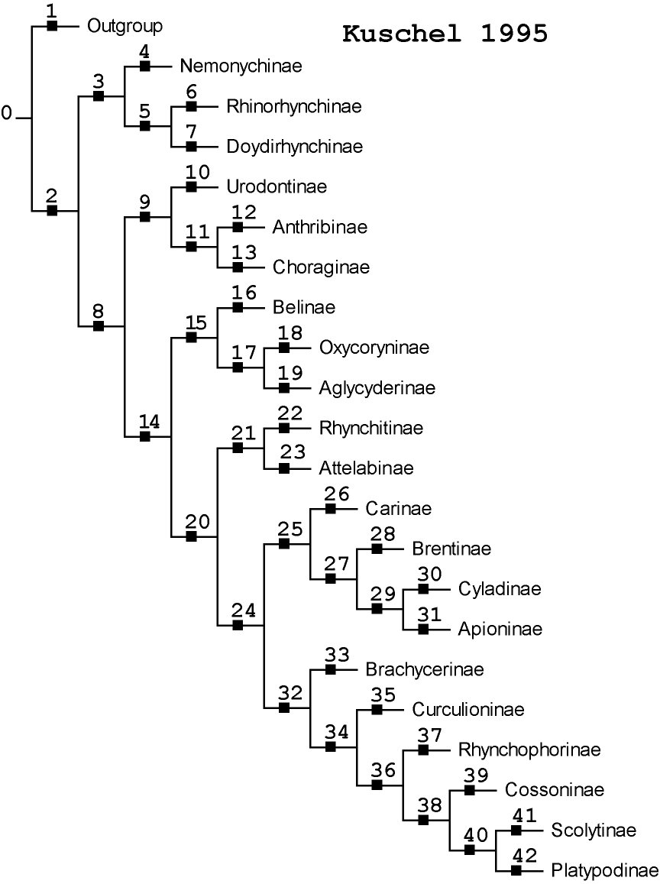
Table 2. Enumeration and vertical (parent-child) relationships of concepts in Kuschel (1995).

1. Concepts sec. Kuschel 1995 |  | 2. Vertical Relationships sec. Kuschel 1995
ConceptID | NameSimple | ConceptID-A | Relationship | ConceptID-B
0 | Outgroup-Ingroup | 42 | is child of | 40
1 | Outgroup | 41 | is child of | 40
2 | Curculionoidea | 40 | is child of | 38
3 | Nemonychidae | 39 | is child of | 38
4 | Nemonychinae | 38 | is child of | 36
5 | Rhinorhynchinae-Doydirhynchinae | 37 | is child of | 36
6 | Rhinorhynchinae | 36 | is child of | 34
7 | Doydirhynchinae | 35 | is child of | 34
8 | Anthribidae-Curculionidae | 34 | is child of | 32
9 | Anthribidae | 33 | is child of | 32
10 | Urodontinae | 31 | is child of | 29
11 | Anthribinae-Choraginae | 30 | is child of | 29
12 | Anthribinae | 29 | is child of | 27
13 | Choraginae | 28 | is child of | 27
14 | Belidae-Curculionidae | 27 | is child of | 25
15 | Belidae | 26 | is child of | 25
16 | Belinae | 32 | is child of | 24
17 | Oxycoryninae-Aglycyderinae | 25 | is child of | 24
18 | Oxycoryninae | 23 | is child of | 21
19 | Aglycyderinae | 22 | is child of | 21
20 | Attelabidae-Curculionidae | 24 | is child of | 20
21 | Attelabidae | 21 | is child of | 20
22 | Rhynchitinae | 19 | is child of | 17
23 | Attelabinae | 18 | is child of | 17
24 | Brentidae-Curculionidae | 17 | is child of | 15
25 | Brentidae | 16 | is child of | 15
26 | Carinae | 20 | is child of | 14
27 | Brentinae-Apioninae | 15 | is child of | 14
28 | Brentinae | 13 | is child of | 11
29 | Cyladinae-Apioninae | 12 | is child of | 11
30 | Cyladinae | 11 | is child of | 9
31 | Apioninae | 10 | is child of | 9
32 | Curculionidae | 14 | is child of | 8
33 | Brachycerinae | 9 | is child of | 8
34 | Curculioninae-Platypodinae | 7 | is child of | 5
35 | Curculioninae | 6 | is child of | 5
36 | Rhynchophorinae-Platypodinae | 5 | is child of | 3
37 | Rhynchophorinae | 4 | is child of | 3
38 | Cossoninae-Platyponinae | 8 | is child of | 2
39 | Cossoninae | 3 | is child of | 2
40 | Scolytinae-Platypodinae | 2 | is child of | 0
41 | Scolytinae | 1 | is child of | 0
42 | Platypodinae

Figure 4. Higher-level classification of weevils sec. Marvaldi & Morrone (2000).

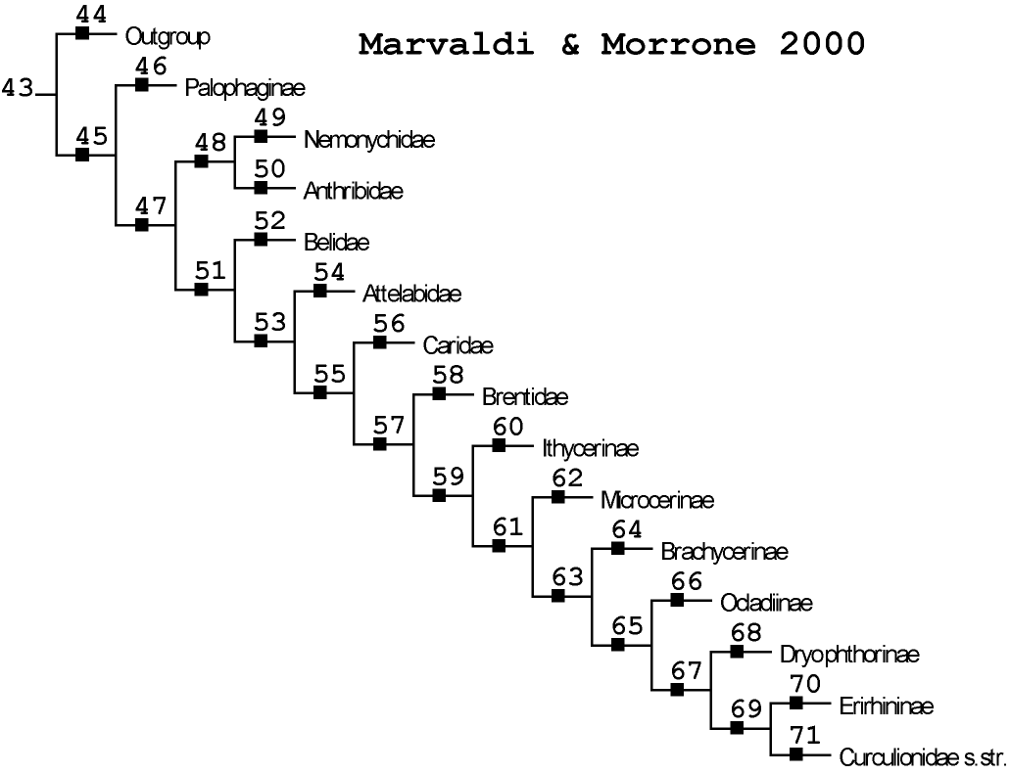

Table 3. Enumeration and vertical relationships of concepts in Marvaldi & Morrone (2000).

1. Concepts sec. M & M 2000 |  | 2. Vertical Relationships sec. M & M 2000
ConceptID | NameSimple | ConceptID-A | Relationship | ConceptID-B
43 | Outgroup-Ingroup | 71 | is child of | 69
44 | Outgroup | 70 | is child of | 69
45 | Palophaginae-Curculionoidea | 69 | is child of | 67
46 | Palophaginae | 68 | is child of | 67
47 | Curculionoidea | 67 | is child of | 65
48 | Nemonychidae-Anthribidae | 66 | is child of | 65
49 | Nemonychidae | 65 | is child of | 63
50 | Anthribidae | 64 | is child of | 63
51 | Belidae-Curculionidae s.str. | 63 | is child of | 61
52 | Belidae | 62 | is child of | 61
53 | Attelabidae-Curculionidae s.str. | 61 | is child of | 59
54 | Attelabidae | 60 | is child of | 59
55 | Caridae-Curculionidae s.str. | 59 | is child of | 57
56 | Caridae | 58 | is child of | 57
57 | Brentidae-Curculionidae s.str. | 57 | is child of | 55
58 | Brentidae | 56 | is child of | 55
59 | Ithycerinae-Curculionidae s.str. | 55 | is child of | 53
60 | Ithycerinae | 54 | is child of | 53
61 | Microcerinae-Curculionidae s.str. | 53 | is child of | 51
62 | Microcerinae | 52 | is child of | 51
63 | Brachycerinae-Curculionidae s.str. | 50 | is child of | 48
64 | Brachycerinae | 49 | is child of | 48
65 | Ocladiinae-Curculionidae s.str. | 51 | is child of | 47
66 | Ocladiinae | 48 | is child of | 47
67 | Dryophthorinae-Curculionidae s.str. | 47 | is child of | 45
68 | Dryophthorinae | 46 | is child of | 45
69 | Erirhininae-Curculionidae s.str. | 45 | is child of | 43
70 | Erirhininae | 44 | is child of | 43
71 | Curculionidae s.str.

Table 4. Lateral concept relationships of weevil concepts in Marvaldi & Morrone (2000) vs.
Kuschel (1995), asserted sec. Franz (2005).

Lateral Relationships sec. Franz 2005
Legend: == congruent, > includes, < is included in, >< overlaps, | excludes
ConceptID M&M 2000 | Relationship | ConceptID Ku 1995
43 | == | 0
44 | < | 1
45 | >< | 1
45 | > | 2
46 | < | 1
47 | == | 2
48 | > | 3
48 | >< | 8
48 | > | 9
49 | == | 3
50 | == | 9
51 | == | 14
52 | == | 15
53 | == | 20
54 | == | 21
55 | == | 24
56 | == | 26
57 | < | 24
57 | >< | 25
57 | > | 32
58 | < | 25
58 | == | 27
59 | == | 32
60 | < | 33
61 | < | 32
61 | >< | 33
61 | > | 34
62 | < | 33
63 | < | 32
63 | >< | 33
63 | > | 34
64 | < | 33
65 | < | 32
65 | >< | 33
65 | > | 34
66 | < | 33
67 | == | 36
68 | == | 37
69 | >< | 34
69 | > | 35
69 | >< | 36
70 | < | 35
71 | >< | 34
71 | >< | 35
71 | >< | 36
71 | > | 38
49 | > | 4
49 | > | 5
49 | > | 6
49 | > | 7
50 | > | 10
50 | > | 11
50 | > | 12
50 | > | 13
52 | > | 16
52 | > | 17
52 | > | 18
52 | > | 19
54 | > | 22
54 | > | 23
58 | > | 28
58 | > | 29
58 | > | 30
58 | > | 31
71 | > | 39
71 | > | 40
71 | > | 41
71 | > | 42
56 + 58 | == | 25
60 + 62 + 64 + 66 | == | 33
69 | == | 34 - 37

To break down one of the more complicated cases: Kuschel (1995) adopted a relatively wide notion of the subfamily Brachycerinae (33) which includes not only Marvaldi & Morrone's Brachycerinae concept (64; therefore 64 < 33), but also their separately recognize subfamilies Ithycerinae (60; 60 < 33), Microcerinae (62; 62 < 33), and Ocediinae (66; 66 < 33). Congruence among the two classifications is obtained through the relationship 60 + 62 + 64 + 66 = = 33.
The "divvying up" of Kuschel's Brachycerinae (33) by Marvaldi and Morrone also means that the latter authors recognize some internal nodes in their almost fully pectinate tree that are in overlap with 33. For example, the node representing concept 65 has the Ocladiinae (65) but no other members of 33. In addition, 65 contains the weevils in the strict sense (67 etc.) which are not part of 33. So then, since 33 and 65 share some members (namely the Ocladiinae) but otherwise each has additional and non-overlapping constituents: 65 >< 33.
Now that we have seen some practical examples of how concepts and their relationships can work, let's look at some visual representations of these kinds of data.

VI. Visualization Tools for Concepts and Their Relationships

A. Martin Graham's Tool – Multiple Hierarchy Version

Martin Graham (Napier University, http://www.dcs.napier.ac.uk/~marting/home.html), a member of SEEK Taxon, is currently refining two related tools for visualizing the relationships of multiple taxonomic hierarchies (Graham et al., 2002). The main display is shown below (Fig. 5; see also Figs. 3 & 4). At present the tool supports formally ranked concepts only. Each individual hierarchy (sec. Kuschel, 1995 vs. sec. Marvaldi & Morrone, 2000) is represented by sets of top-to-bottom nested bars with subordinate, ranked concepts. Their names are searchable ("Taxa List") and navigation up and down the hierarchy is possible through clicking on specific concepts or expanding the little icon on the top left. Color coding (here in pink, but see Fig. 6) is used to visualize concept relationships. In this example, the Brachycerinae sec. Kuschel are selected and the four immediately related concepts in Marvaldi & Morrone's (2000) scheme light up as well. A blue pop-up box then displays the specific relationships among these five concepts, as provided in Table 4.

Figure 5. Two weevil classifications as represented by one of Martin Graham's tools.

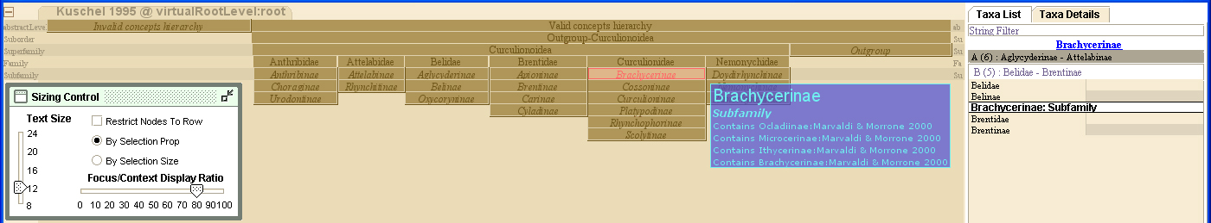
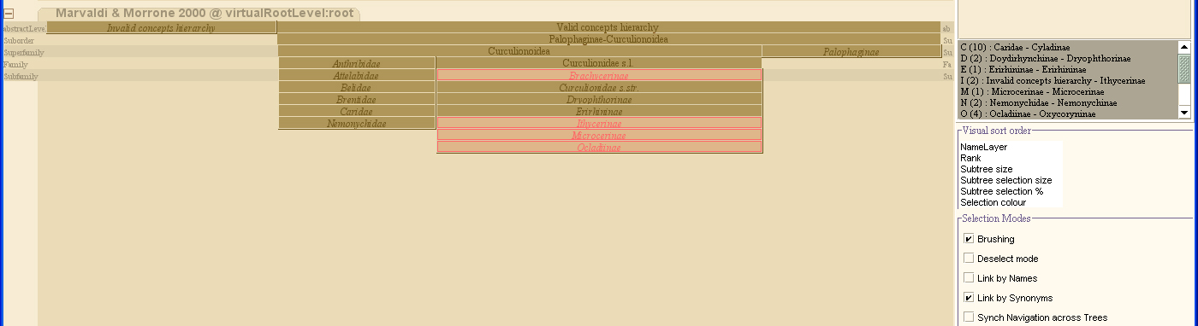

Even though this display form is somewhat unusual compared to how systematists normally visualize taxonomic hierarchies, it has numerous advantages. Foremost among them is the ability to handle many separate hierarchies (say, 5-10), each with hundreds of internal concepts – and navigate within and between them without losing one's orientation or visually overlaying too much information. This capacity is show in Fig. 6 with an unrelated example of umbellifer plant concepts (1824-1916), particularly for multiple concepts of the genus Molopospermum.

Fig. 6. Six classifications of umbellifers (Molopospermum) as displayed in Martin Graham's tool.

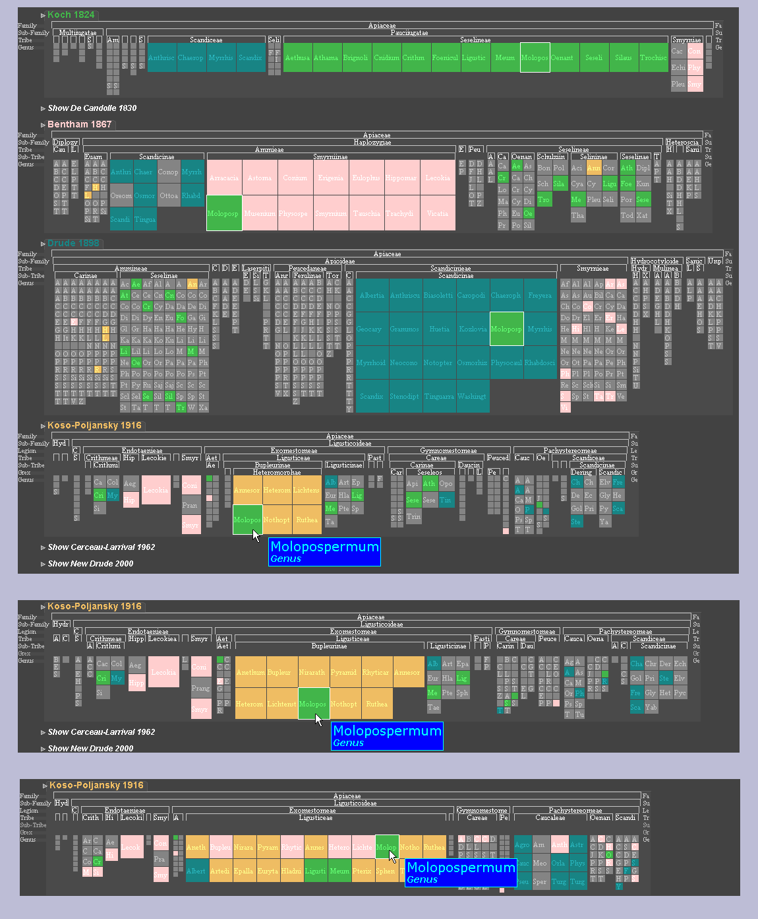
B. Martin Graham's Tool – Graph Version

Martin Graham's other tool uses "star-like" tree displays, where the "root" is located centrally and subordinate concepts are peripheral. Using the weevil example once more, a relatively complex screenshot with all concept relationships (Table 4) is shown in Fig. 7. Again, color coding is used to display internal (parent-child) vs. external relationships, where there latter can be of five different kinds.

Figure 7. Two weevil classifications and all their lateral concept relationships as represented by one of Martin Graham's tools.

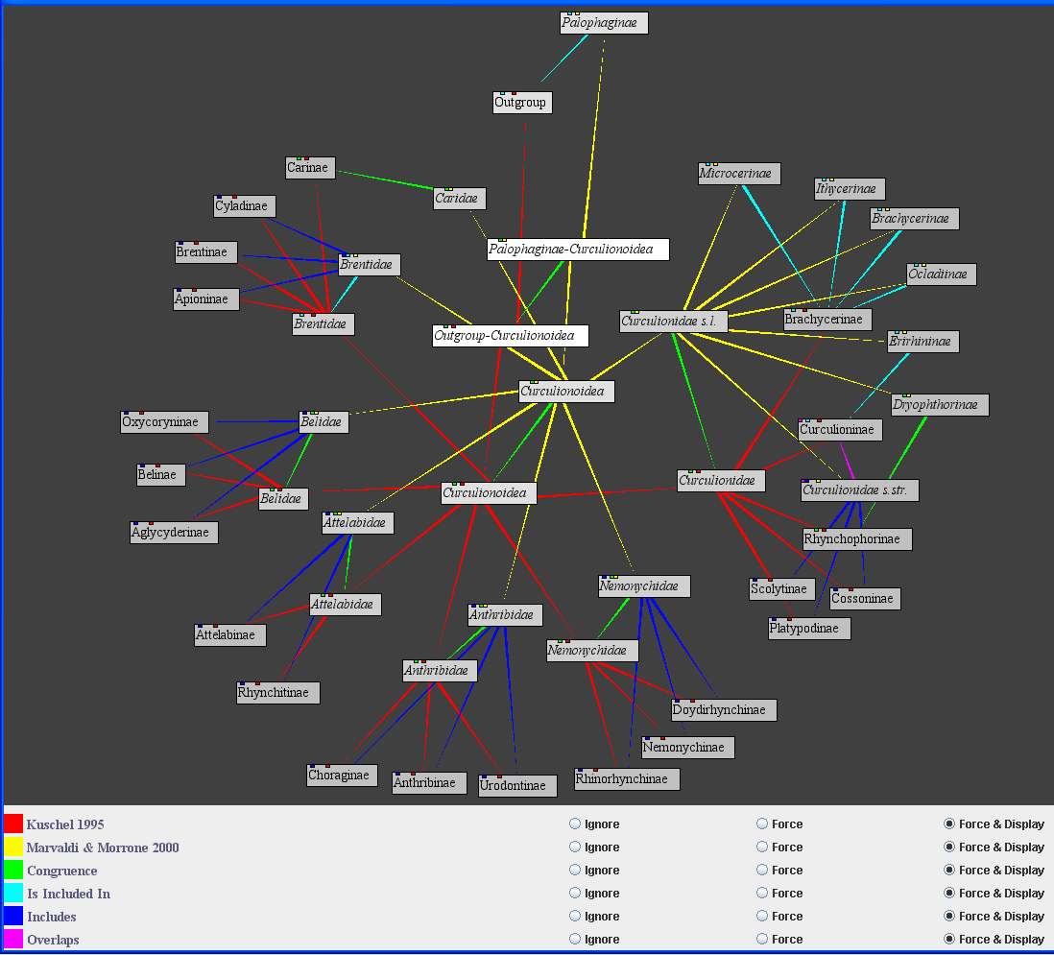

To filter out the message from this display more easily, focus first on the red branches (Kuschel, 1995), then on the yellow branches (Marvaldi & Morrone, 2000) which are consistently shifted upward and (mostly) to the right. Then selectively track the green branches ("congruence") one by one, etc. The aforementioned Brachycerinae example (with Kuschel's concept being more inclusive) is located in the top right corner.
This display form is more intuitive to systematists because of its branch/node tree structures, but it becomes difficult to use for larger data sets (Fig. 8). "Hyperbolic tree displays" may reduce the problem (e.g. http://darwin.zoology.gla.ac.uk/~rpage/MyToL/www/find_name_form.php, enter "Insecta," then select NCBI – Classification – Hyperbolic View).

Figure 8. Eight classifications of umbellifers (Caucalis) as displayed in Martin Graham's tool.

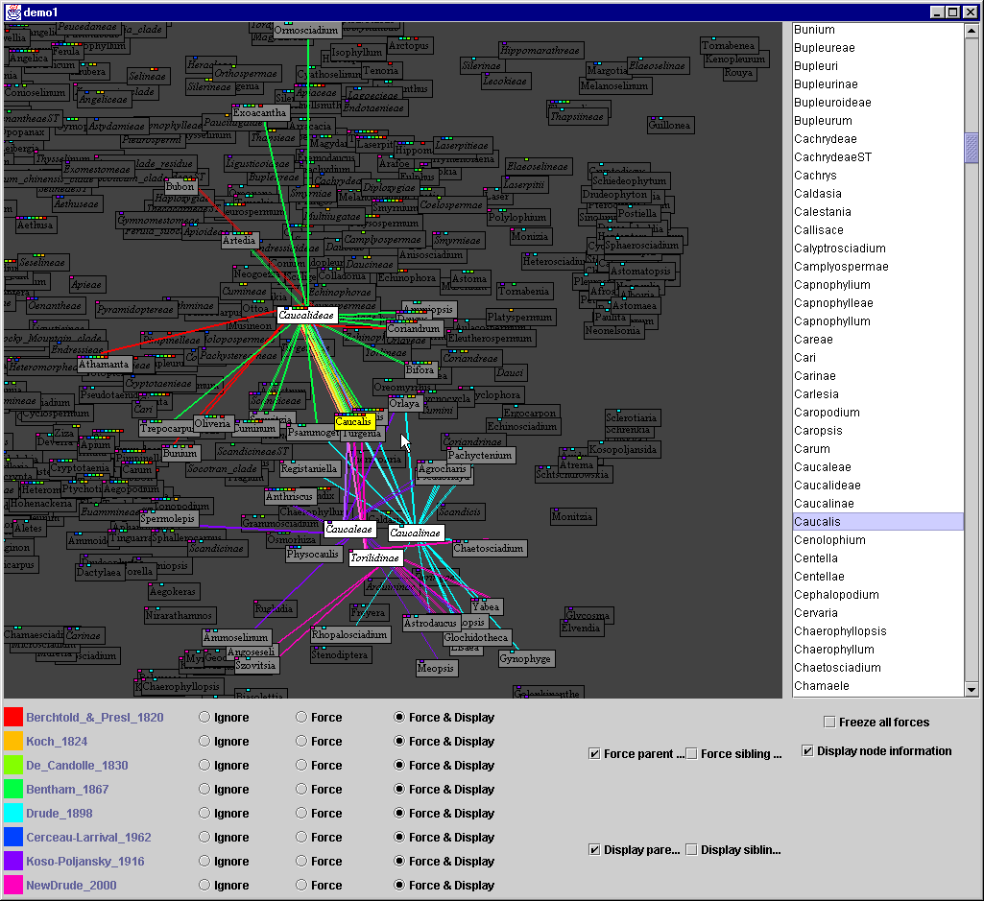

Both tools by Martin Graham are being further refined at present to meet visualization challenges and become fully integrated with the TOS. Xianhua Liu, another SEEK Taxon member, has also experimented with these kinds of display forms.

C. Schema Matching Tool SCIA

The following application has a rather different origin and will only be introduced briefly. UCSD Researchers affiliated with SEEK are developing a generic schema matching tool "SCIA" (Wang & Goguen, 2004). The tool has an interface which allows specification of various types of concept matches (linguistic, structural, context checking) and mappings. It generates displays for two hierarchically arranged schemas, in indented text form on a left and right panel (Fig. 8). It exemplifies a simpler, more low-key approach to displaying two (possibly taxonomic) classifications and the connections between their constituents.

Figure 9. Graphic user interface for the SCIA schema matching tool (Wang & Goguen, 2004).

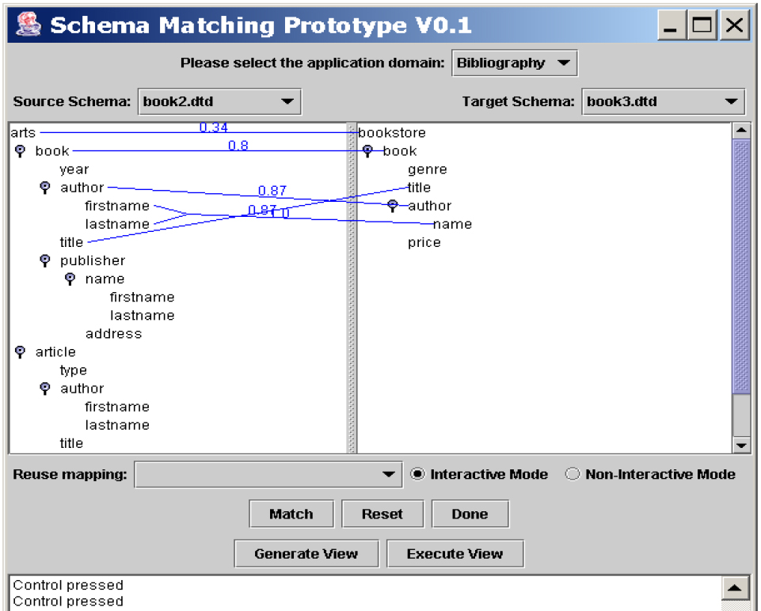

D. DoubleTree

The DoubleTree visualization tool has been developed by researchers at the University of Maryland (Parr et al., 2004; see also http://www.cs.umd.edu/hcil/biodiversity/ - downloading the 0.7 zip file and playing with DoubleTree is fun and highly recommended!). The DoubleTree source code has been made available to SEEK Taxon. Its very neat large- to small-scale transition features are due to SpaceTree ( http://www.cs.umd.edu/hcil/spacetree/), a more generic program. Like the SCIA interface, DoubleTree is limited to displaying no more than two hierarchies. Furthermore, in its present form the only means of displaying connections between individual constituents of each classification is by highlighting matching name strings (e.g. "Insecta"). The user must then infer any taxonomic similarities and differences by exploring the lower-level contents of each name.
Users tend to find the bifurcating, left-to-right oriented tree displays in DoubleTree quite intuitive and similar to their preferred single-tree outputs (Lee et al., 2004). Again, its two-tree coordination, automatic shrinking-and-expanding features are best understood by simply using the program. A typical screenshot is shown in Fig. 10. DoubleTree does a pretty good job of accommodating large trees without overloading the screen, but it cannot compete with Martin Graham's first tool in that regard. In short, we think it has potential, but it needs work to fit our concept taxonomy purposes.

Fig. 10. Screenshot of DoubleTree interface with selection of Insectivora in two classifications.

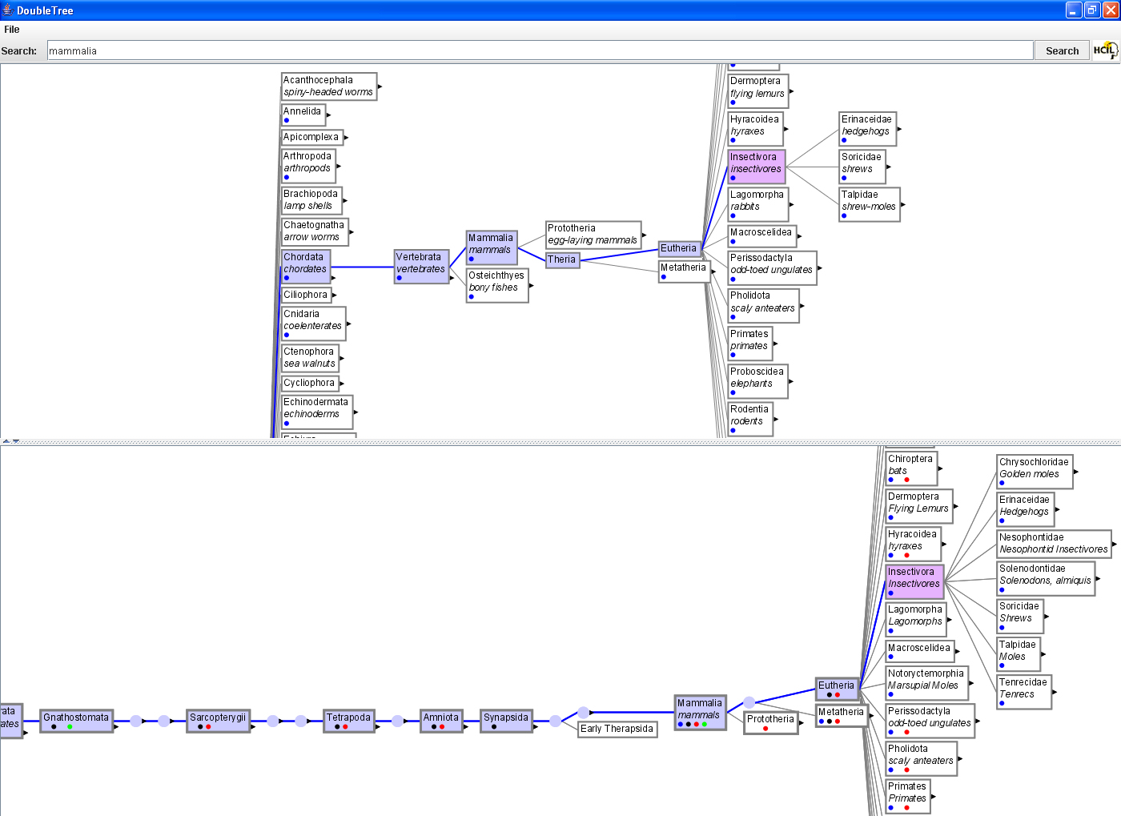

E. Other Tools

There are several other tools that more or less approach our vision and needs. For example, members of MoreTax project (http://www.bgbm.org/BioDivInf/Projects/MoreTax/default.htm) have already produced a concept taxonomy editor (Fig. 11). It "sits on top" of a database quite similar to the SEEK TOS. End users are able to explore multiple alternative classifications and – whenever available – relationships between their individual concepts. However, the expert entering concept information can only see his/her own classification, not that of others. Furthermore, the Taxonomic Editor does not support tree diagrams, only indented lists of ranked concepts. At the moment a select group of European botanists can access the tool to enter new information. The MoreTax project has a significant conservationist aspect.

Fig. 11. Screenshot of a species concept (Pilularia townsendill Pomel sec. a particular [unnamed] expert), as represented in the MoreTax taxonomic editor.

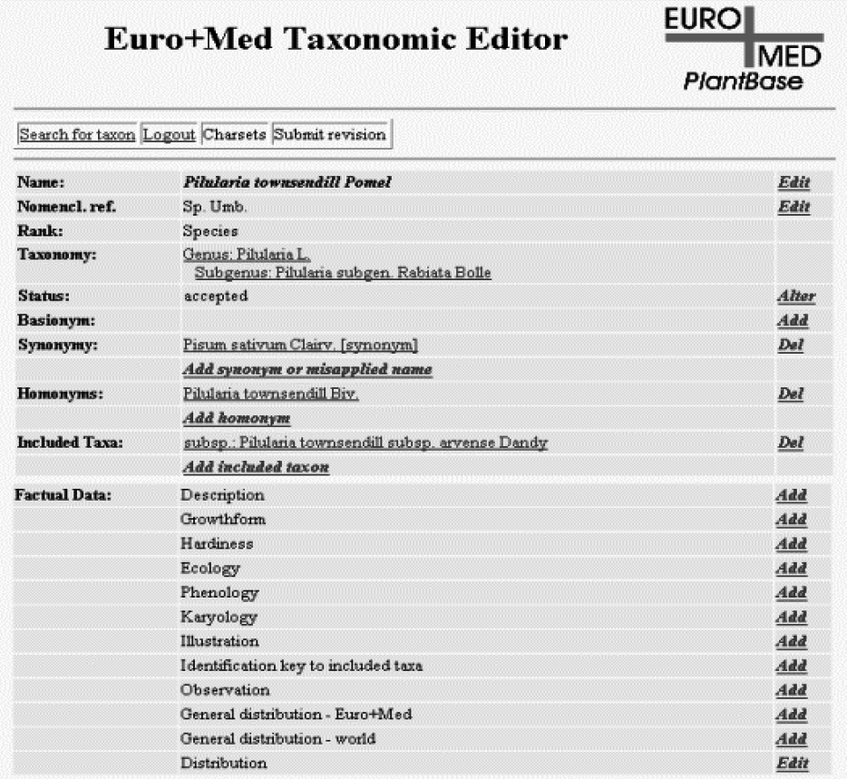

Database specialists in Japan and the United Kingdom have produced TaxoNote (http://www.nomencurator.org/InfoVis2003/submitted/), a relatively simple tool for visualizing multiple hierarchies and exploring their contents name by name (Fig. 12). TaxoNote is based on the Nomencurator database (Ytow et al., 2001) which does not promote a full-blown concept perspective, at least not in terms of allowing lateral set theory relationships to act as separately handled concept connectors. The form of display, however, is intuitive and quite efficient.

Fig. 12. Screenshot of three concepts of the whale genus Lipotes, as represented in TaxonNote.

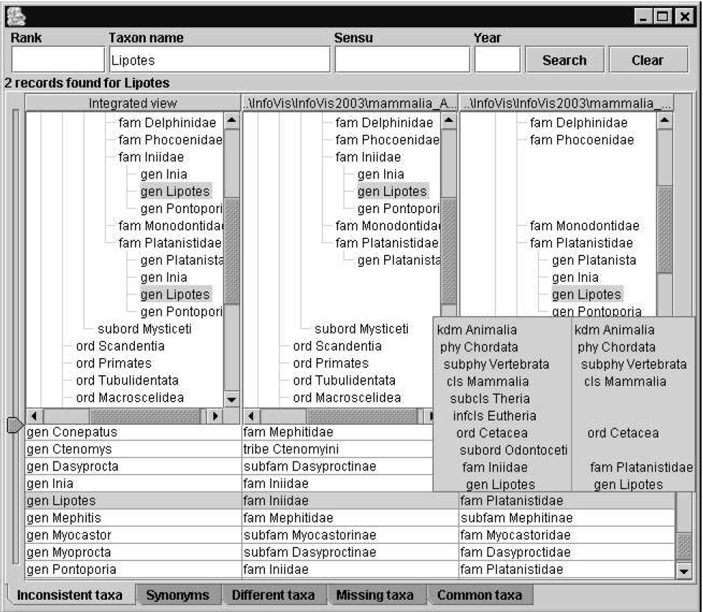

Finally, TreeJuxtaposer (http://www.cs.ubc.ca/~tmm/papers/tj/) is a capable tool for comparing the color-coded structures of two phylogenetic trees (possibly of larger size) while maintaining visual clarity (Fig. 13). According to the website, the TreeJuxtaposer's features "result in a system delivering a fluid exploration experience that scales both in the size of the dataset and the number of pixels in the display. We have based the design decisions for our system on the needs of a target audience of biologists who must understand the structural details of many phylogenetic, or evolutionary, trees" (see http://www.cs.ubc.ca/~tmm/papers/tj/tj.camready.pdf). Like DoubleTree, using TreeJuxtaposer is very intuitive and educational; downloading the video demonstrations on the website is highly recommended. However, at present it does not support a full-blown concept perspective and the expression of set theory relationships.

Fig. 13. Screenshot of two phylogenetic trees for numerous genera of composites (Asteraceae), as represented in the TreeJuxtaposer. The colors label comparable sections in each tree.

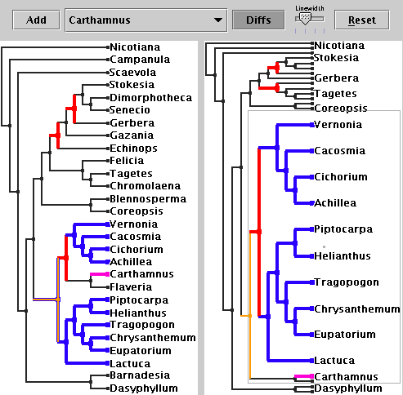

VII. In Preparation for the Albuquerque Design Sessions

To recap: SEEK Taxon is working towards an infrastructure that can capture all kinds of taxonomic emendations and alternate views on a particular group of taxa, not just those that require nomenclatural changes. To express such concept lineages we advocate using the "sec." abbreviation; it ties the taxonomic definition of a name to an individual author and thereby allows experts to establish relationships among couplets of concepts. The relationships themselves are expert assessments. They may take into account as much as detail as provided in the respective taxonomic definitions (see also Appendix 1). We recommended using a set of five set theory relationship symbols: = =, >, <, ><, and | (see Section V.A.). These are combinable with AND/OR to express uncertainty, or with +/- to yield more congruence between two classification schemes. Based on the concept holdings of the TOS and input from our taxonomic experts, we want to build a tool optimized for asserting and displaying such relationships.
To prepare well for the design sessions in Albuquerque, our two experts should do the following:

- Read through this primer carefully, take note of any passages that are difficult to understand,
any questions for clarification, other remarks, etc.;

- Look at some of the referenced websites and on-line demonstrations (e.g. for Matrin Graham's
tools, DoubleTree, TreeJuxtaposer, etc.);

- Think about a potential group of taxa within their area of expertise; 10-20 currently recognized
species would be sufficient; any interesting ecological angles would be neat; (considerable)
taxonomic instability over time too;

- Think of 5-10 authoritative treatments dealing with this focal group; by this we mean works
that were/are commonly cited as references for the nomenclature and taxonomy of the group,
e.g. Wilson & Reeder (1993) and suitable predecessors (can be very old), but also older or
contemporary monographs, popular and important regional literature, etc.

- If possible, bring copies of these works to the design session in Albuquerque; they will give us
a good idea as to what kinds of data will go into the concept definitions and relationship
assertions and how this information can be slotted into the TOS; they will also help us delimit
the information scope for the tree displays;

- As time permits, try to prepare for asserting relationships among the concepts advocated in
several of the treatments; i.e. familiarize themselves with the information that went into the
definitions and see if they can assign the "correct" symbol (congruent, overlap, etc.) for
connecting their meanings.

VIII. References

Berendsohn, W. G. 1995. The concept of "potential taxa" in databases. Taxon 44: 207-212.
Graham, M., M. F. Watson & J. B. Kennedy. 2002. Novel visualisation techniques for working
with multiple, overlapping classification hierarchies. Taxon 51: 351-358.
Koperski, M., M. Sauer, W. Braun & S. R. Gradstein. 2000. Referenzliste der Moose
Deutschlands. Schriftenreihe für Vegetationskunde 34: 1-519.
Kuschel, G. 1995. A phylogenetic classification of Curculionoidea to families and subfamilies.
Memoirs of the Entomological Society of Washington 14: 5-33.
B. Lee, C. S. Parr, D. Campbell & B. Bederson. 2004. How users interact with biodiversity
information using TaxonTree. Proceedings of Advanced Visual Interfaces (AVI 2004, ACM
Press): 320-327.
Marvaldi, A. E. & J. J. Morrone. 2000. Phylogenetic systematics of weevils (Coleoptera:
Curculionidae): a reappraisal based on larval and adult morphology. Insect Systematics &
Evolution 31: 43-58.
Parr, C. S., B. Lee, D. Campbell & B. Bederson. 2004. Tree visualizations for taxonomies and
phylogenies. Bioinformatics 20: 2997-3004.
Wang, G. & J. Goguen. 2004. Analysis for schema matching tool user interface design.
Technical Report, Department of Computer and Engineering, UCSD. Available at
http://www.cse.ucsd.edu/users/guilian/reports/ui_analysis.pdf
Weakley, A. S. (ed.). 2005. Flora of the Carolinas, Virginia, and Georgia. Draft, 875 pp.
Ytow, N., D. R. Morse & D. M. Roberts. 2001. Nomencurator: a nomenclatural history model to
handle multiple taxonomic views. Biological Journal of Linnean Society 73: 81-98.

IX. Appendix 1: Mini-Introduction to the SEEK Taxonomic Object Service

SEEK's Taxonomic Object Service (TOS) is an on-line database system whose structure is modeled after an XML Schema that was mainly developed by SEEK Taxon members at Napier University (Figs. 14 & 15). A detailed overview of the latter project and its progress is available at http://www.soc.napier.ac.uk/tdwg/index.php?pagename=HomePage. The Schema was designed to capture and transfer taxonomic concept information from many variable sources in a generalized, standard format. It is compatible with the most advanced and most highly populated on-line taxonomic databases available today. Our taxonomic experts need to be familiar with the Schema at a general level: its structure reveals what kind of information taxonomic concepts contain, and how this information is slotted into the TOS. Note that dotted lines point to "optional information."

Fig. 14. Overview of TOS Schema structure. Metadata cover information about the process of entering the concept information. Vouchers and Publications handle details about specimens and literature references. These parts of the Schema are not further dissected here. The remaining two elements are viewed in more detail in Fig. 15.

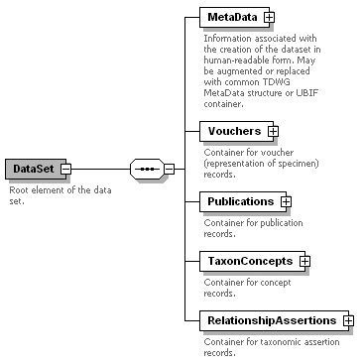

Fig. 15. Taxonomic concepts and relationship assertions, as represented in the TOS Schema. A TaxonConcept entry minimally consists of a Name (much detail about name formation, spelling, authorship and ranking is hidden therein) plus an AccordingTo ("sec." author/Publication). The meaning of a concept can be variously specified through the listing of included specimens (SpecimenCircumscription: types, other examined material), a textual diagnosis (Character Circumscription), and via Relationships to similar or included concepts. Links to external information (e.g. GenBank) are possible too. The RelationshipAssertions are handled separately. They typically include two concepts, an expert asserter, and a particular nomenclatural or taxonomic relationship (see Section V.A.).



